**Malawi Use Case**

**Data Dictionary**

**Version – 1 0**



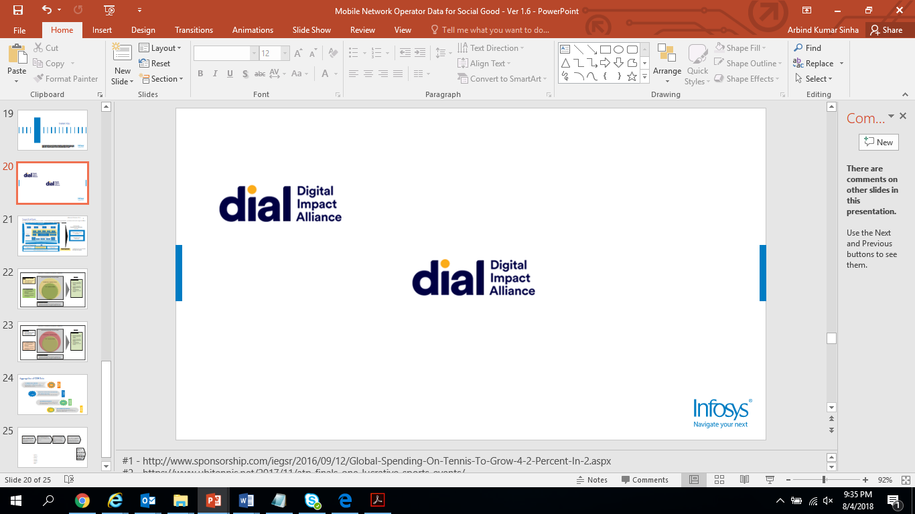

Document Information and Revision History

| **Version** | **Date** | **Author** | **Reviewer** | **Remarks** |
| --- | --- | --- | --- | --- |
| 1 0 | 14/09/2018 | Infosys | Infosys | Draft version |
|  |  |  |  |  |

**Table of Contents**

1.0 Introduction 4

2.0 Data and Data Sources 4

3.0 Data – Call Detail Records (CDR) 4

3.1 About the data 4

3.2 Schema 4

4.0 Data – District / Site Lookup Files 5

4.1 About the data 5

4.2 Schema 5

4.3 Key Considerations 6

5.0 Data – CH District Data Summary 6

5.1 About the data 6

5.2 Schema 6

5.3 Key Considerations 7

6.0 Data – Airtel MW_Database 8

6.1 About the data 8

6.2 Schema 8

6.3 Key Considerations 8

7.0 Data – Geography_Master 8

7.1 About the data 8

7.2 Schema 8

7.3 Key Considerations 9

8.0 Data – Health Post Catchment Population Data 9

8.1 About the data 9

8.2 Schema 9

8.3 Key Considerations 10

9.0 Data – Facebook High Resolution Settlement Layer 10

9.1 About the data 10

9.2 Schema 10

9.3 Key Considerations 10

10.0 Data – Administrative Boundary shape files 10

10.1 About the data 10

10.2 Schema 11

10.3 Key Considerations 12

11.0 Data – Malawi Burden of Disease Data - Annual by Facility 12

11.1 About the data 12

11.2 Schema 12

11.3 Key Considerations 12

12.0 Data – Population Projection Data 12

12.1 About the data 12

12.2 Schema 13

12.3 Key Considerations 13

# Introduction

This document covers details of data, data sources and associated data dictionaries.

# Data and Data Sources

Data requirements for the use case –

|  |  |
| --- | --- |
| Data | Source of data |
| CDR data | AirTel Malawi |
| Administrative shapefiles (TA and GVHs) | [www.diva-gis.org/gdata](http://www.diva-gis.org/gdata) (GIS data) |
| Facebook High Resolution Settlement Layer | Facebook |
| Population projection [2008-2030] | Cooper / Smith |
| CH District data summary [2017] | Cooper / Smith |
| Catchment population | Cooper / Smith |
| Malawi Burden of Disease Data | Cooper / Smith |
| Geography_Master | Cooper / Smith |
| Airtel MW_Database | AirTel Malawi |
| District / Site Lookup Files (*covers Tower locations (e.g. LAT/LONG, district, regions, etc.))* | AirTel Malawi |

# Data – Call Detail Records (CDR)

## About the data

This data covers details like call descriptions, call initiation mobile #, call termination mobile #, LAC Id, Cell Id and call duration for SMS and voice.

## Schema

| **File** | **Columns** | **Data Type** | **Description** | **Remarks** |
| --- | --- | --- | --- | --- |
| MNO - SMS and Voice | USAGE_CALL_DESCRIPTION | Text | Type of call made-SMS, voice call, roaming, etc. |  |
| CALL_ORIGINATING_NUMBER | Alpha Numeric | Mobile number from which call was made (sender) |  |
| CALL_TERMINATING_NUMBER | Alpha Numeric | Mobile number to which call was made(receiver) |  |
| CALL_START_DATE | Date (mm/dd/yyyy) | Date the call was made |  |
| CALL_START_TIME | Time (hh: min: sec) | Time of the call |  |
| LAC_ID | Numeric | Location Area code from where the call was initiated |  |
| CELL_ID | Numeric | Unique Number used to identify each Base Transceiver Station (BTS) |  |
| CALL_DURATION | Numeric | Duration of the call |  |

# Data – District / Site Lookup Files

## About the data

These files have details of Tower locations (e.g. LAT/LONG, district, regions, etc.)

## Schema

| **File** | **Columns** | **Data Type** | **Description** | **Remarks** |
| --- | --- | --- | --- | --- |
| Lookup Files used:   1. MW LTE Classification file 10072018 update, 2. 2G Classification file_14072018 (003) and 3. 3G MW Site Database 15072018 | Siteid | Alpha Numeric | Site ID where the tower is located | Referenced as Siteid, SITE, SiteID in the 3 lookup files |
| SiteName | Text | Site Name of the tower location | Referenced as Sitename, Site Name, SITE_NAME in the 3 lookup files |
| LAC_ID | Numeric | Location Area code from where the call was initiated | Referenced as TAC,LAC ID,LAC in the 3 lookup files |
| CELL_ID | Numeric | Unique Number used to identify each Base Transceiver Station (BTS) | Referenced as CI, CELL_ID, UCell in the 3 lookup files |
| DISTRICT | Text | District of tower location | Referenced as CITYID, District in the 3 lookup files |
| LONG | Longitude | Longitude of tower location |  |
| LAT | Latitude | Latitude of tower location |  |

## Key Considerations

Only those columns are considered from look up files which can be helpful in connecting MNO data with Tower Id and LAT/Long.

# Data – CH District Data Summary

## About the data

This data can be used to understand community health system as per district population (covered/un-covered), HSA data, Bicycle data and Health Indicators.

## Schema

| **File** | **Sheet Name** | **Column Name** | **Data Type** | **Description** |
| --- | --- | --- | --- | --- |
| CH District Data Summary 2017 | District Summary | District | Text | District Name |
| Investment Priority | Numeric | Investment Priority |
| Total population | Numeric | Total population of the District |
| Uncovered Population | Numeric | Population not covered under Govt. Health Scheme |
| % uncovered Population | Numeric | %Population not covered under Govt. Health Scheme |
| Proposed Health Posts | Numeric | Number of Health Posts proposed to be setup |
| Target Health Posts | Numeric | Number Health Posts targeted to be setup |
| HTRA | Numeric | hard to reach - areas that are more than 5km away from a health facility |
| Total HSAs | Numeric | HSAs + SHSAs |
| HSAs | Numeric | Health Surveillance Assistants in June 2017 |
| HSA to Population ratio | Numeric | Population/HSAs |
| SHSAs | Numeric | Senior HSAs |
| HAS to SHSA ratio | Numeric | SHSAs/HSAs |
| Total HSAs | Numeric | Health Surveillance Assistants in Sept 2017 |
| Number without bicycles | Numeric | Number of HSAs without Bicycles |
| % without bicycles | Numeric | % of HSAs without Bicycles |
| Neonatal Mortality rate | Numeric | neonatal mortality rate in the year 2016 |
| % of under 1 fully immunized | Numeric | % of under 1 fully immunized in the year 2016 |
| Vitamin A Coverage | Numeric | Vitamin A Coverage in the year 2016 |
| Health Posts | District | Numeric | District Name |
| Health Posts by year | Numeric | Health Posts to be setup in 5 years |
| Total | Numeric | Manual adjustment of unedited total |
| Unedited Total | Numeric | Total number of Health Posts |
| DHIS 2 | Organization Unit | Numeric | Name of the Health Facility |
| Neonatal Mortality rate | Numeric | From 2012-2016 |
| Penta III Coverage | Numeric | From 2012-2016 |
| % of under 1 fully immunized | Numeric | From 2012-2016 |
| Vitamin A Coverage | Numeric | From 2012-2016 |
| Bicycles by District | District | Numeric | District Name |
| Total HSAS | Numeric | HSAs in Sept 2017 |
| Number with bicycles | Numeric | Number of HSAs with Bicycles |
| Number without bicycles | Numeric | Number of HSAs without Bicycles |
| HR Data | Row labels | Numeric | Different Council names in each District |
| HSAs | Numeric | HSAs in June 2017 |
| SHSAs | Numeric | SHSAs in June 2017 |

## Key Considerations

We have requested CH District Data Summary data for the year 2016. But we did not get this data.

# Data – Airtel MW_Database

## About the data

This data can be used to understand Cell Tower information with longitude and latitude.

## Schema

| **File** | **Sheet Name** | **Column Name** | **Data Type** | **Description** |
| --- | --- | --- | --- | --- |
| Airtel MW_Database_18062018 | Cell Info | Site Id | Text | Unique Id of the site |
| Cell id | Numeric | Unique Id of the Cell |
| Town | Text | Name of the town |
| Coordinates Data | 2G Site ID | Text | Unique Id of 2G site |
| Lat | Latitude | Latitude of 2G site Id |
| Long | Longitude | Longitude of 2G site Id |
| Site Name | Text | Site name |

## Key Considerations

We have Cell Tower information with longitude and latitude shared.

# Data – Geography_Master

## About the data

This data can be used to provide details of Cell Id, Lac Id as per Local government accountability (LGA) for all states of Malawi.

## Schema

| **File** | **Column Name** | **Data Type** | **Description** |
| --- | --- | --- | --- |
| Geography_Master | COUNTRY_NAME | Text | Country name |
| REGION_DESCRIPTION | Text | Region descriptions |
| ZONE_CODE | Text | Zone code of the region |
| STATE_CODE | Text | State code of Malawi |
| STATE_DESCRIPTION | Text | State name of Malawi |
| LGA_ID | Numeric | Local government accountability Id |
| LGA_CODE | Text | Local government accountability code |
| LGA_DESCRIPTION | Text | Local government accountability |
| SITE_CODE | Text | Site code of LGA |
| SITE_NAME | Text | Site name of LGA |
| SITE_DESCRIPTION | Text | Site name of LGA |
| CELL_CODE | Text | Cell code |
| CELL_NAME | Text | Cell name |
| CELL_DESCRIPTION | Text | Cell description |
| LAC_ID | Numeric | Location Area Code |
| CI_ID | Numeric | Cell Id details |

## Key Considerations

None.

# Data – Health Post Catchment Population Data

## About the data

This data provides master list of health facility with the catchment population. Catchment population is available for facility type, dispensary, health center, health post and hospital.

## Schema

|  |  |  |  |  |
| --- | --- | --- | --- | --- |
| **File Name** | **Column Name** | **Data Type** | **Description** | **Remarks** |
| Master List Free Service Health Facilities in Malawi 20 July 2018 | Facility Name | Text | Facility Name |  |
| Village | Text | Village name |  |
| GVH | Text | Group village head |  |
| TA | Text | Traditional authorities |  |
| District | Text | District name |  |
| Region | Text | Region name |  |
| Eastings | Number | Eastings |  |
| Northings | Number | Northings |  |
| Datum | Text | Datum |  |
| Facility Type | Text | Type of facility |  |
| Controlling Agency | Text | Name of controlling agency |  |
| Name | Text | Name of person |  |
| Phone | Number | Phone number |  |
| Email | Email | Email address |  |
| Cluster | Text | Name of cluster |  |
| Status | Text | Functional status |  |
| Date | Date | Date |  |
| Facility Code | Number | Facility code |  |
| 2018 Catchment | Number | Catchment population for 2018 |  |
| 2017 Catchment | Number | Catchment population for 2017 |  |
| 2016 Catchment | Number | Catchment population for 2016 |  |
| 2015 Catchment | Number | Catchment population for 2015 |  |

## Key Considerations

This covers population coverage within 5 Kms radius of a given health facility.

# Data – Facebook High Resolution Settlement Layer

## About the data

These files provide estimates of population distribution across Malawi.

## Schema

|  |  |  |  |  |
| --- | --- | --- | --- | --- |
| **File Name** | **Band Category** | **Data Type** | **Description** | **Remarks** |
| High Resolution Settlement Layer-Facebook data-hrsl_mwi.tif | Band 1 / POP | Numeric  (raw file-Image) | Number of people estimated to live in each pixel |  |
| Band 2 / Settlement | Numeric  (raw file-Image) | A mask representing pixels within which one or more buildings was detected with a value of 1 |  |
| Band3 / Clouds | Numeric  (raw file-Image) | A mask representing pixels that contained clouds in the source imagery with a value of 1 |  |

## Key Considerations

To come up with these estimates convolutional neural network and computer vision techniques were used.

# Data – Administrative Boundary shape files

## About the data

These shapefiles contain the administrative boundaries detail of Malawi as per traditional authorities (TA) / group village heads (GVHs) level.

## Schema

| **File Name** | **Columns** | **Data Type** | **Description** | **Remarks** |
| --- | --- | --- | --- | --- |
| MWI_adm1.shp | ID_0 | Categorical | Country ID |  |
| ISO | text | Country code |  |
| NAME_0 | text | Country Name |  |
| ID_1 | Categorical | District ID |  |
| NAME_1 | text | District name |  |
| TYPE_1 | text | Administrative level type |  |
| ENGTYPE_1 |  |  |  |
| NL_NAME_1 |  |  |  |
| VARNAME_1 | text | Alternate name for district |  |
| MWI_adm2.shp | ID_0 | Categorical | Country ID |  |
| ISO | text | Country code |  |
| NAME_0 | text | Country Name |  |
| ID_1 | Categorical | District ID |  |
| NAME_1 | text | District name |  |
| ID_2 | Categorical | Administrative second level ID |  |
| NAME_2 | text | Administrative second level name |  |
| TYPE_2 | text | Administrative second level type |  |
| ENGTYPE_2 |  |  |  |
| NL_NAME_2 |  |  |  |
| VARNAME_2 | text | Alternate name for district |  |
| MWI_adm3.shp | ID_0 | Categorical | Country ID |  |
| ISO | text | Country code |  |
| NAME_0 | text | Country Name |  |
| ID_1 | Categorical | District ID |  |
| NAME_1 | text | District name |  |
| ID_2 | Categorical | Administrative second level ID |  |
| NAME_2 | text | Administrative second level name |  |
| ID_3 | Categorical | Administrative third level ID |  |
| NAME_3 | text(alphanumeric) | Administrative third level name |  |
| TYPE_3 | text | Administrative third level type |  |
| ENGTYPE_3 |  |  |  |
| NL_NAME_3 |  |  |  |
| VARNAME_3 | text | Names of each individual GVH | Only unknown enteries |

## Key Considerations

None

# Data – Malawi Burden of Disease Data - Annual by Facility

## About the data

This file provides details of # of patients treated / services provided for the year 2012-2016 disease-wise at health centers.

## Schema

|  |  |  |  |  |
| --- | --- | --- | --- | --- |
| **File Name** | **Columns** | **Data Type** | **Description** | **Remarks** |
| Malawi Burden of Disease Data - Annual by Facility | Organization Unit | Text | Name of the health center Organization Unit |  |
| Columns ‘B’ to ‘IQ’ | Number | # of patients treated / service provided |  |

## Key Considerations

This covers # of patients treated / services provided for the year 2012-2016 disease-wise at health centers.

# Data – Population Projection Data

## About the data

This file provides population estimates for the year 2008 to 2030 district-wise.

## Schema

| **File Name** | **Columns** | **Data Type** | **Description** | **Remarks** |
| --- | --- | --- | --- | --- |
| Population by SNU 2008-2030 : Sheet1 | YEAR | Numeric | Year |  |
|  | INDICATOR | Integer | ID for Indicator label |  |
|  | INDICATOR_LABEL | Text | Type of Indicator (here Population) |  |
|  | ADMINISTRATIVE LEVEL 2 | Integer | ID for Administrative level 2 |  |
|  | ADMINISTRATIVE LEVEL 2_LABEL | Text | Name of the Administrative level 2(District Name) |  |
|  | VALUE | Numeric | Population value |  |
|  | FLAG | Logical gate | highlight a district of interest |  |
|  | FLAG_LABEL | Logical gate | highlight a district of interest |  |
|  | UNIT | Integer | ID for the unit used to describe VALUE column |  |
|  | UNIT_LABEL | Text | Units in which VALUE column is described |  |

## Key Considerations

Source of this data is National Statistical Office, Malawi.